Play With Bootstrap
Send Feedback

Let's start practicing Bootstrap. If you face any problem, search for it on the web and look into the documentation of Bootstrap.

You might also need to write your own CSS code for some styles. But first, try to use Bootstrap for the desired style.

On a large screen and above, it looks like -
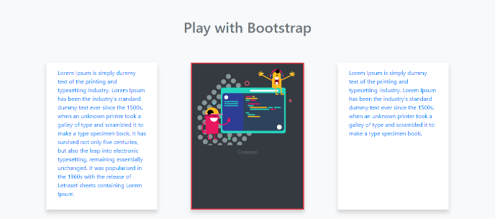

On a medium screen and above, it looks like -
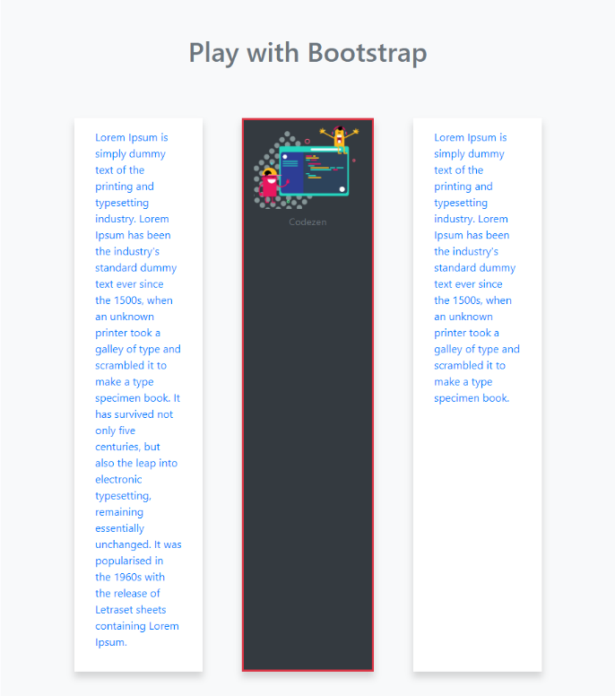

On a small screen and above, it looks like -
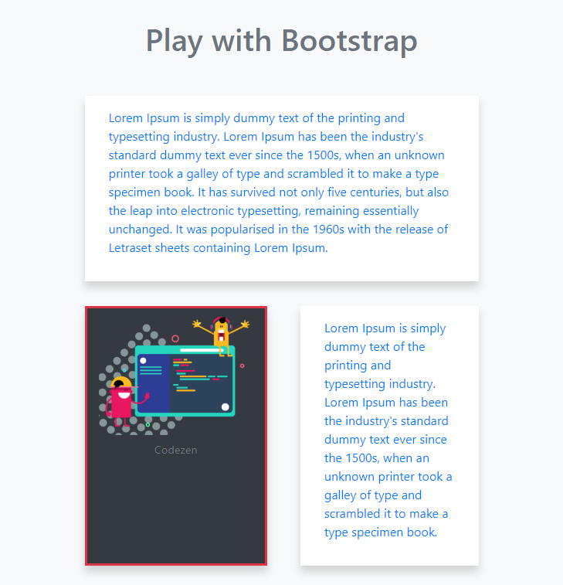

On a small screen and below, it looks like -
